SCELBI Oscilloscope Digital Board Rework Instructions
There is only one known surviving SCELBI OSCILLOSCOPE Display Interface. It is presently in storage at the Computer History Museum’s offsite storage facility.

The digital board has rework on it that brings the design into alignment with surviving schematics. Since I don’t know of any oscilloscope boards that were made that match the schematics without added rework, my reproductions match the surviving board. The rework that must be done in order to bring the design up to the revision seen in the schematics is presented in this document. There are other ways to achieve the same result. This method is selected because it is how it was done on the surviving board.

There is also a capacitor on the input of Z21-3. I presume that the purpose of this is to slow down the transition time of this signal, but I will only be able to verify this when I actually build a reproduction.

Images of original SCELBI Oscilliscope Digital board courtesy of Jack Rubin.

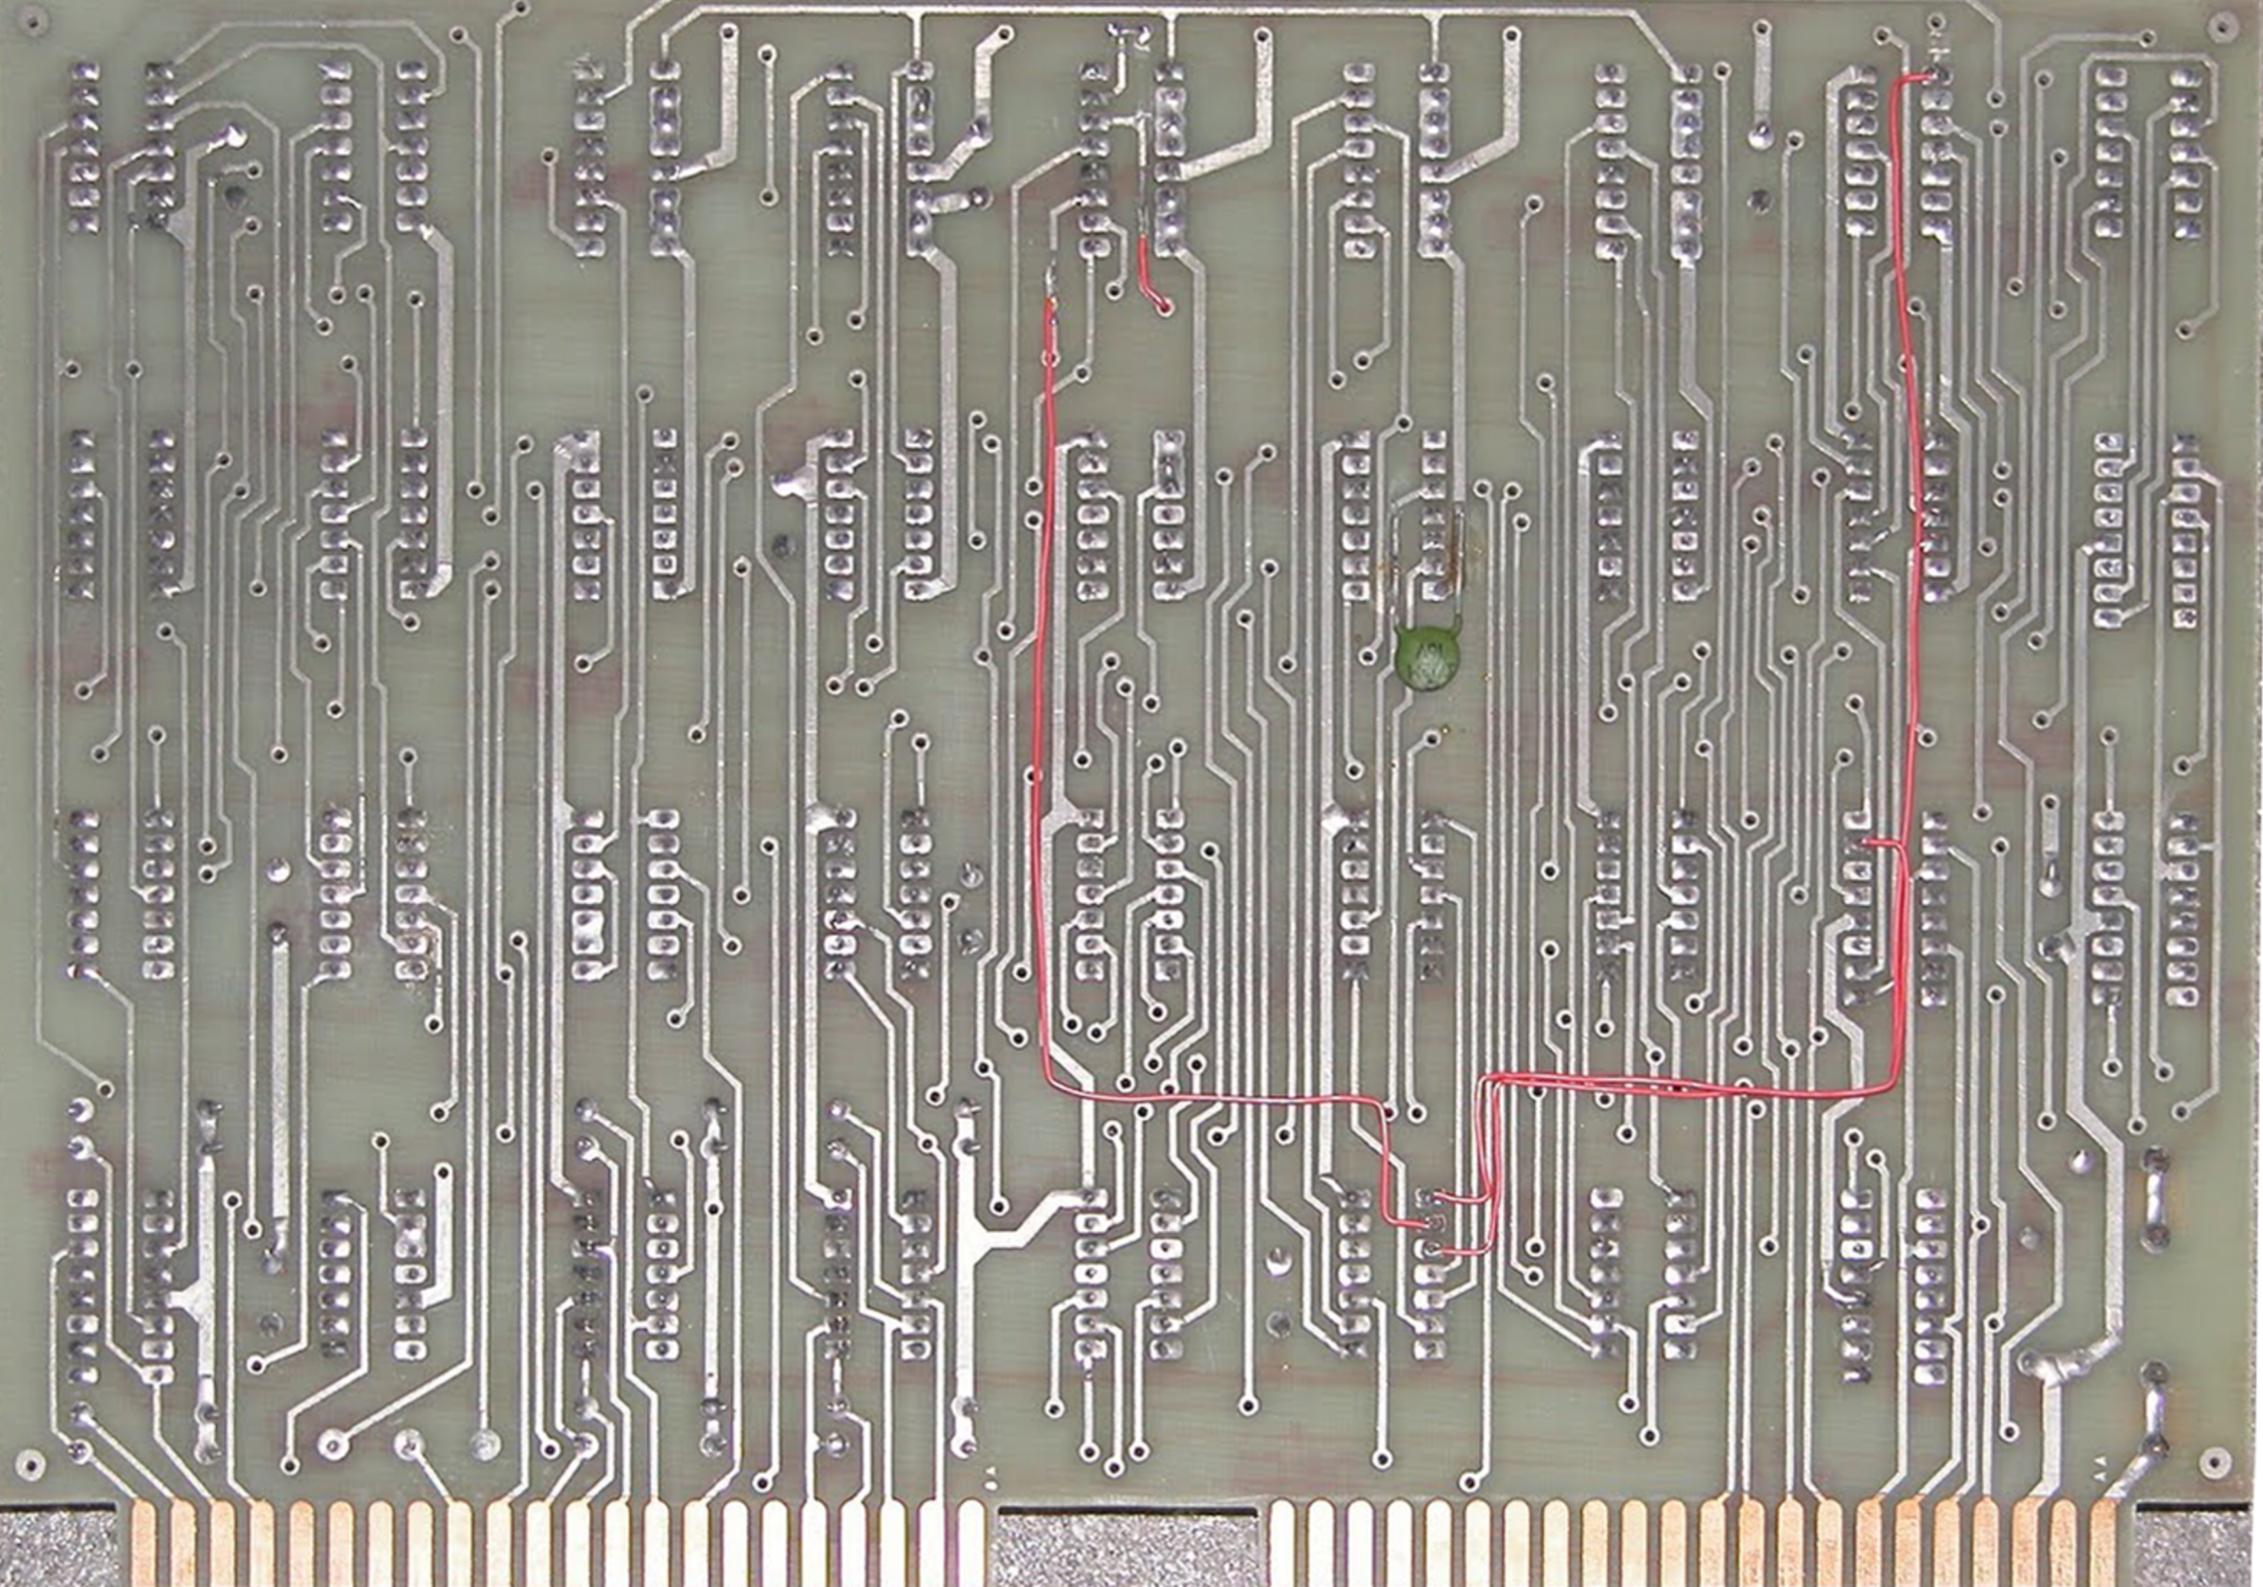

Cuts – 3 traces cut
- back of board - Isolate Z28 - pin 1 from via
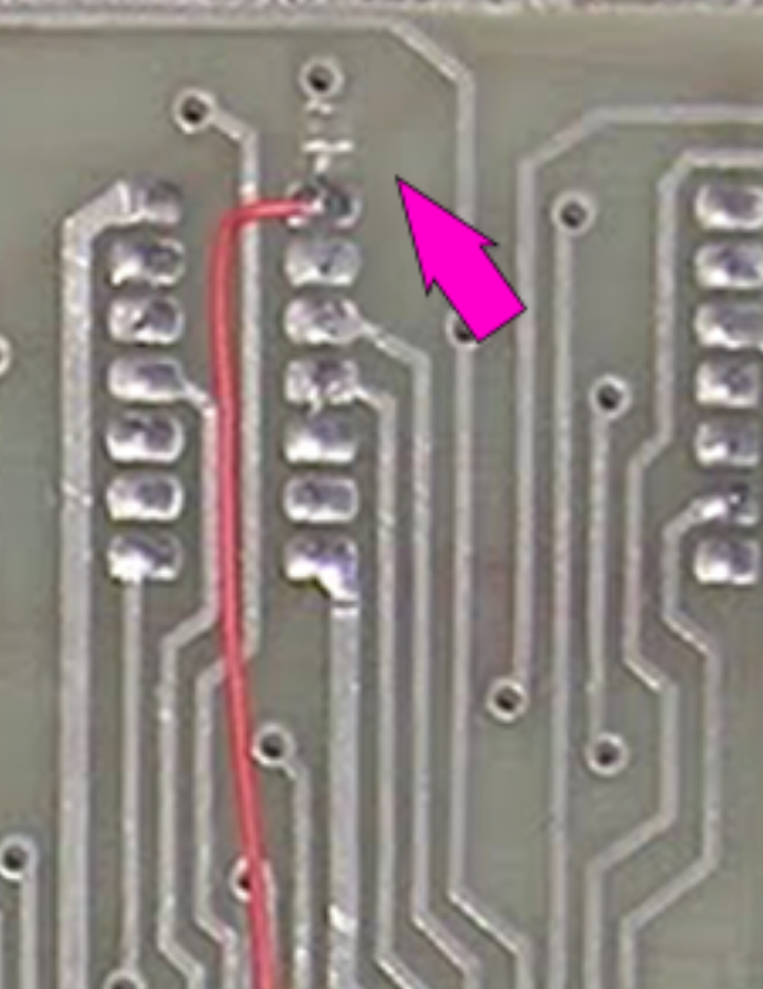

- back of board - Trace near Z21 - Pins 1-2 - Isolate Z31-pin 14 from via near pin 1 - do not isolate from trace going to via near pin Z31 -pin 8
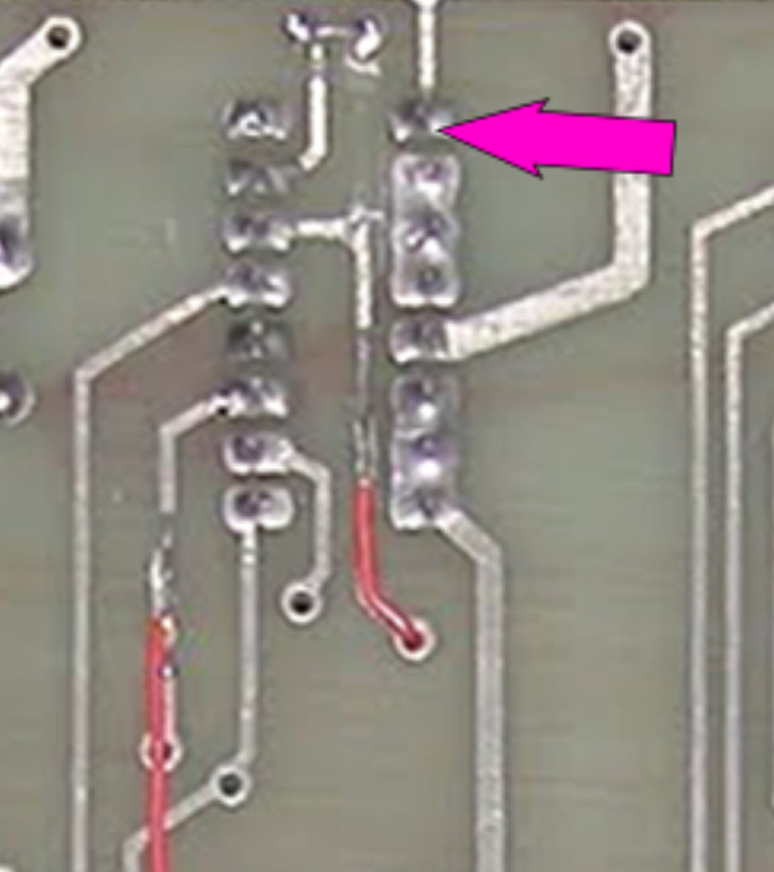

- front of board - between top and second row cut trace coming from illustrated via, between chips Z22, Z23, Z31, Z32
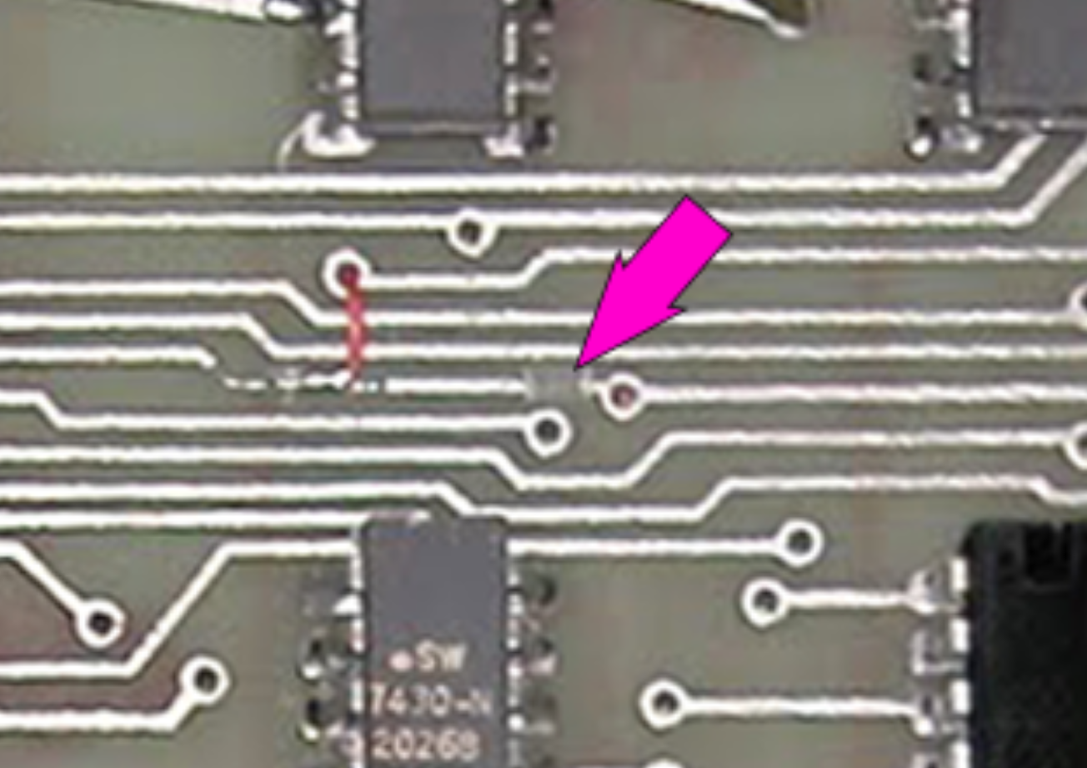

Adds – 5 wires added
- back of board: Z3 – pin 1 to Z28 – pin 1
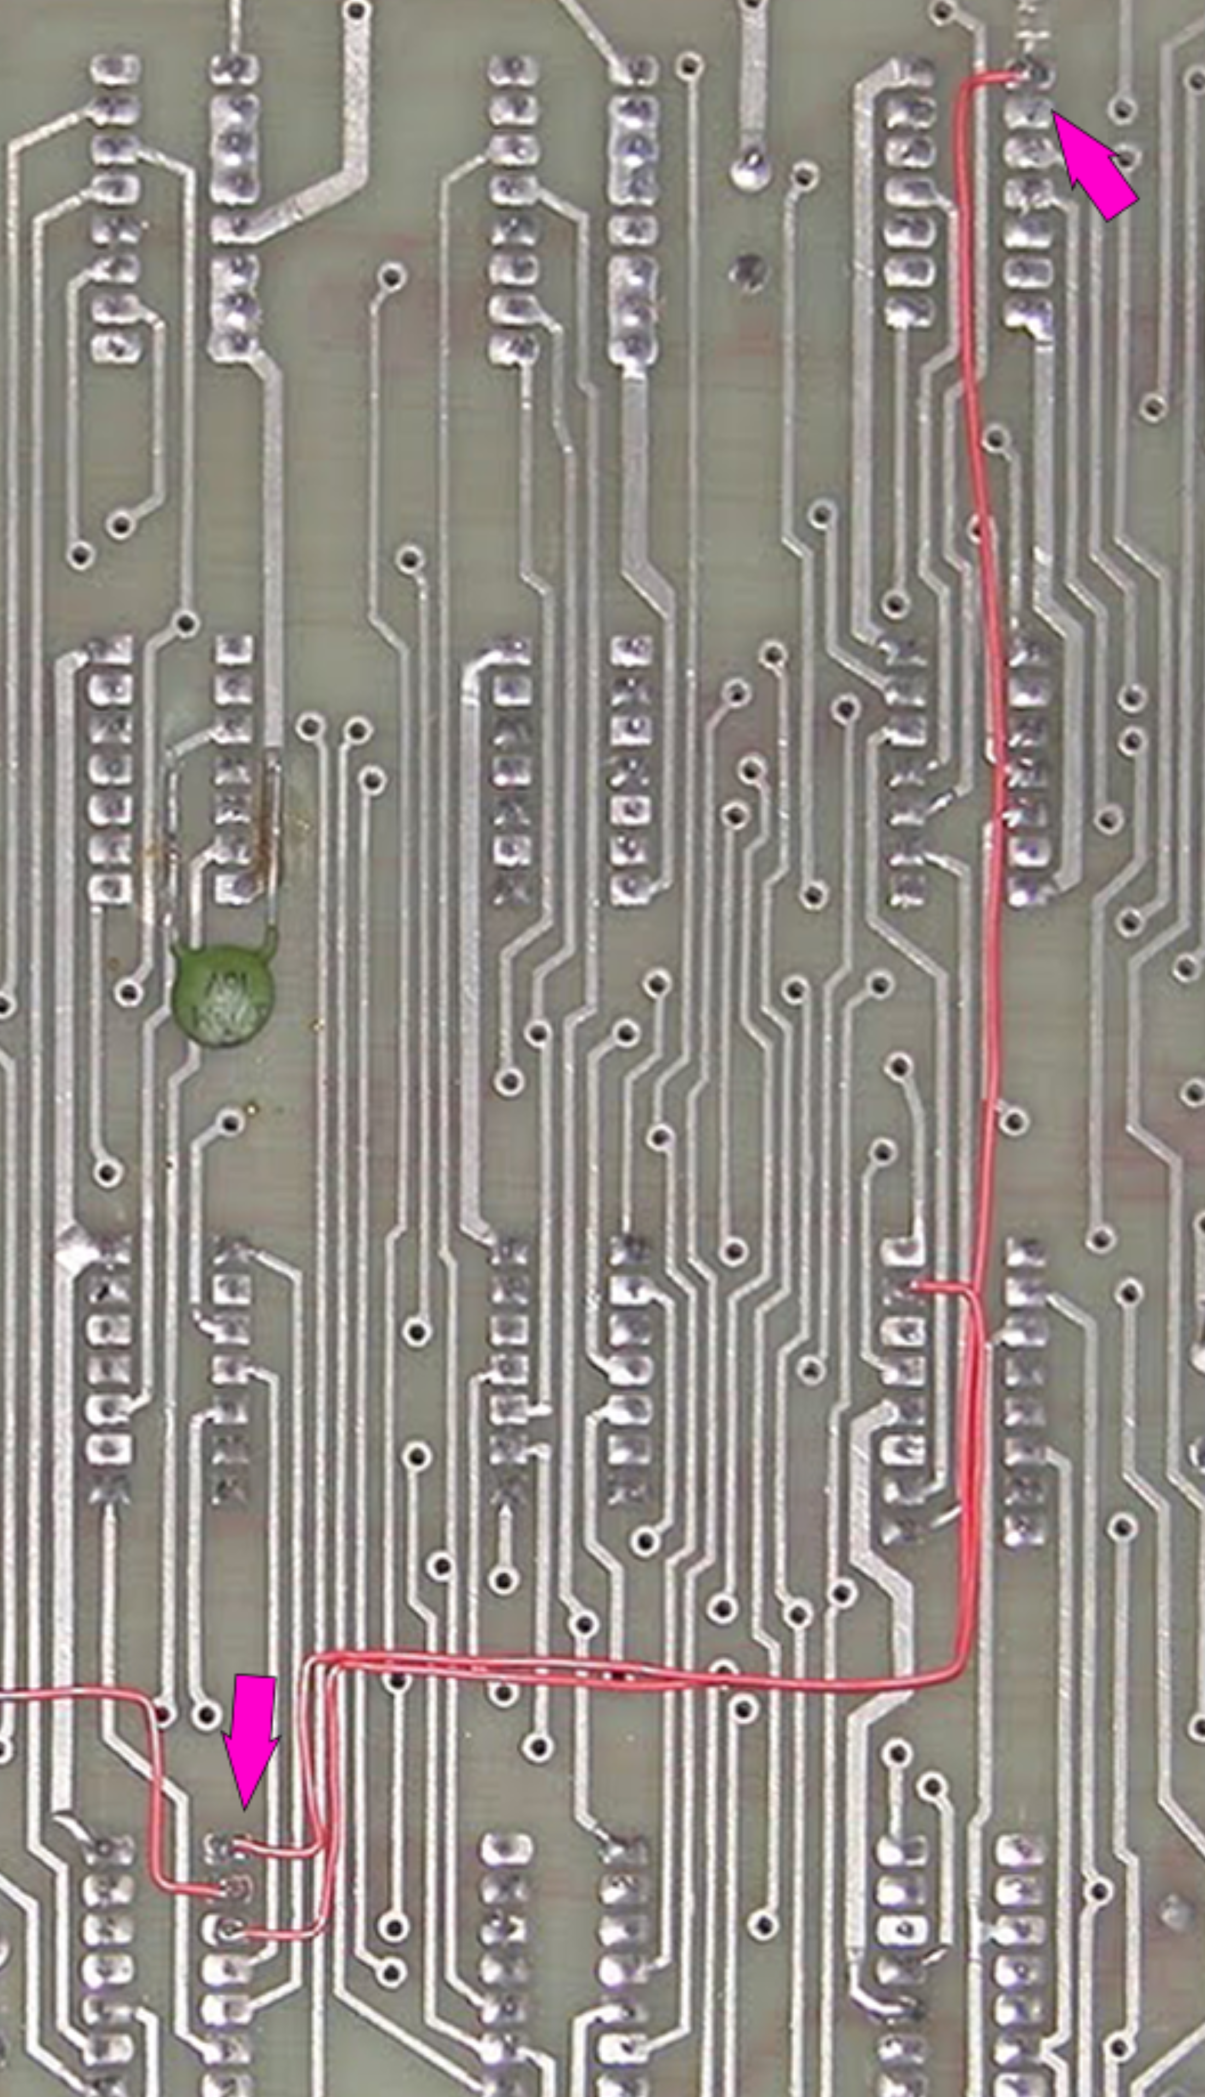
- back of board: Z3 – pin 2 to trace leading to Z31 - pin 11
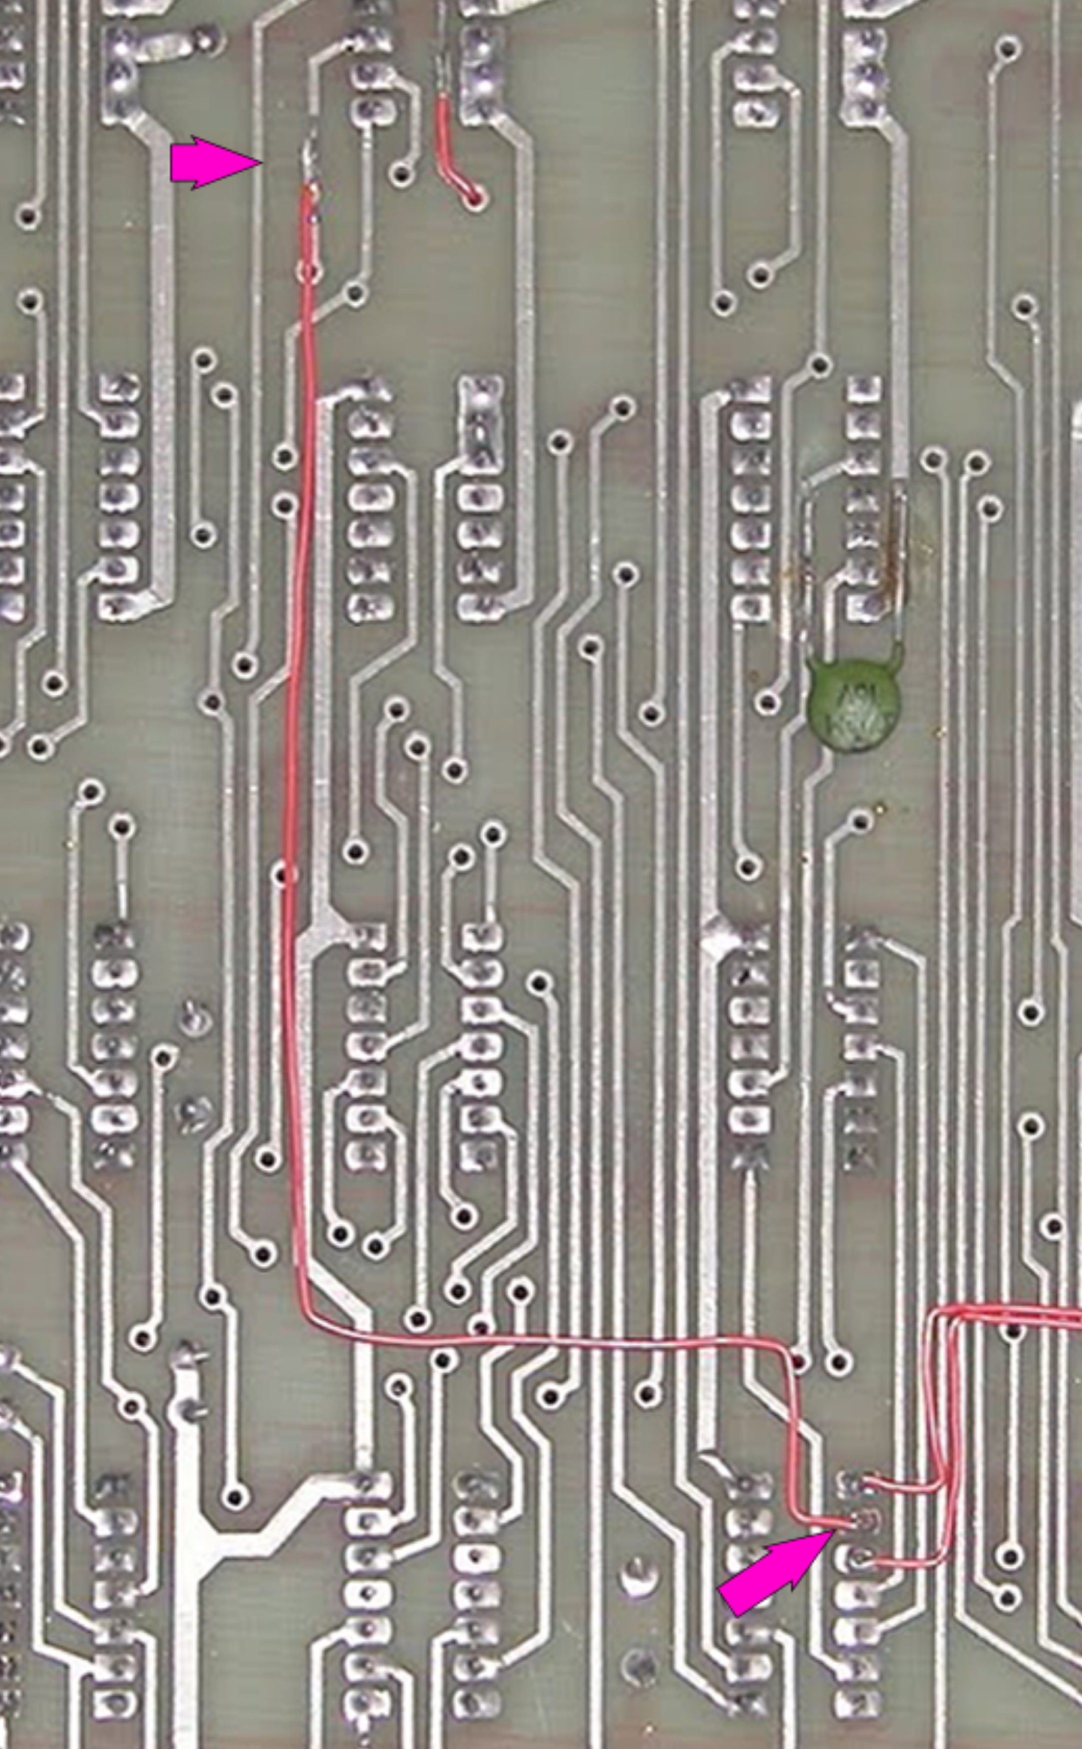

- back of board – Z3 – pin3 to Z10 pin 15
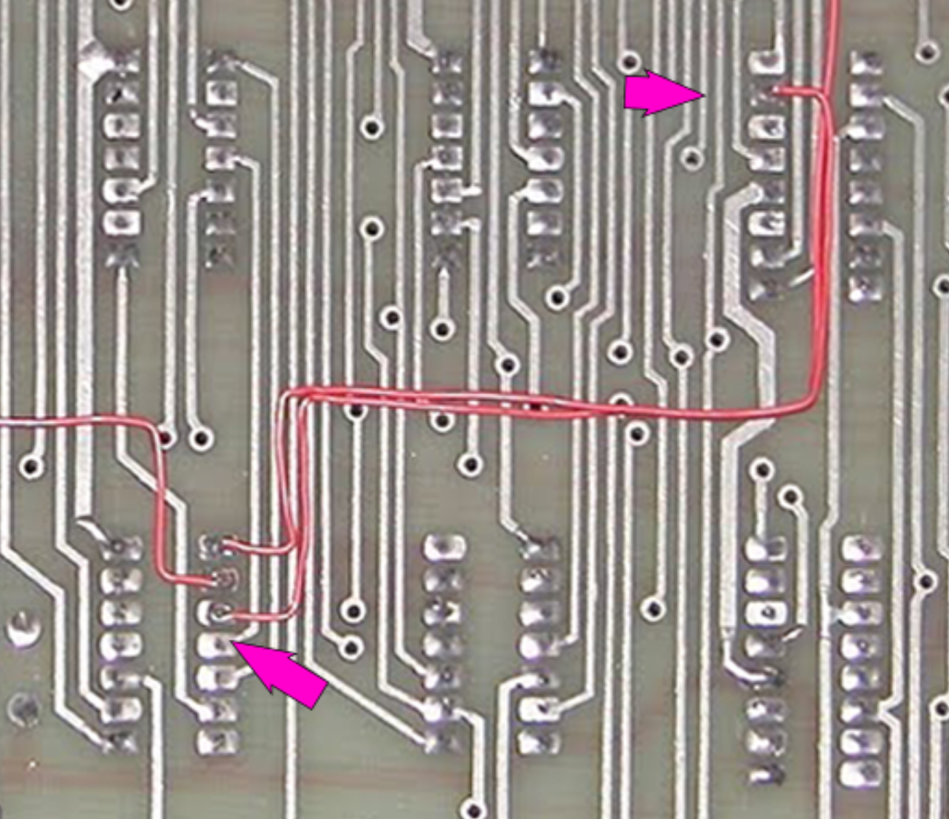

- back of board – between two vias near Z31 pins 1 and pins 16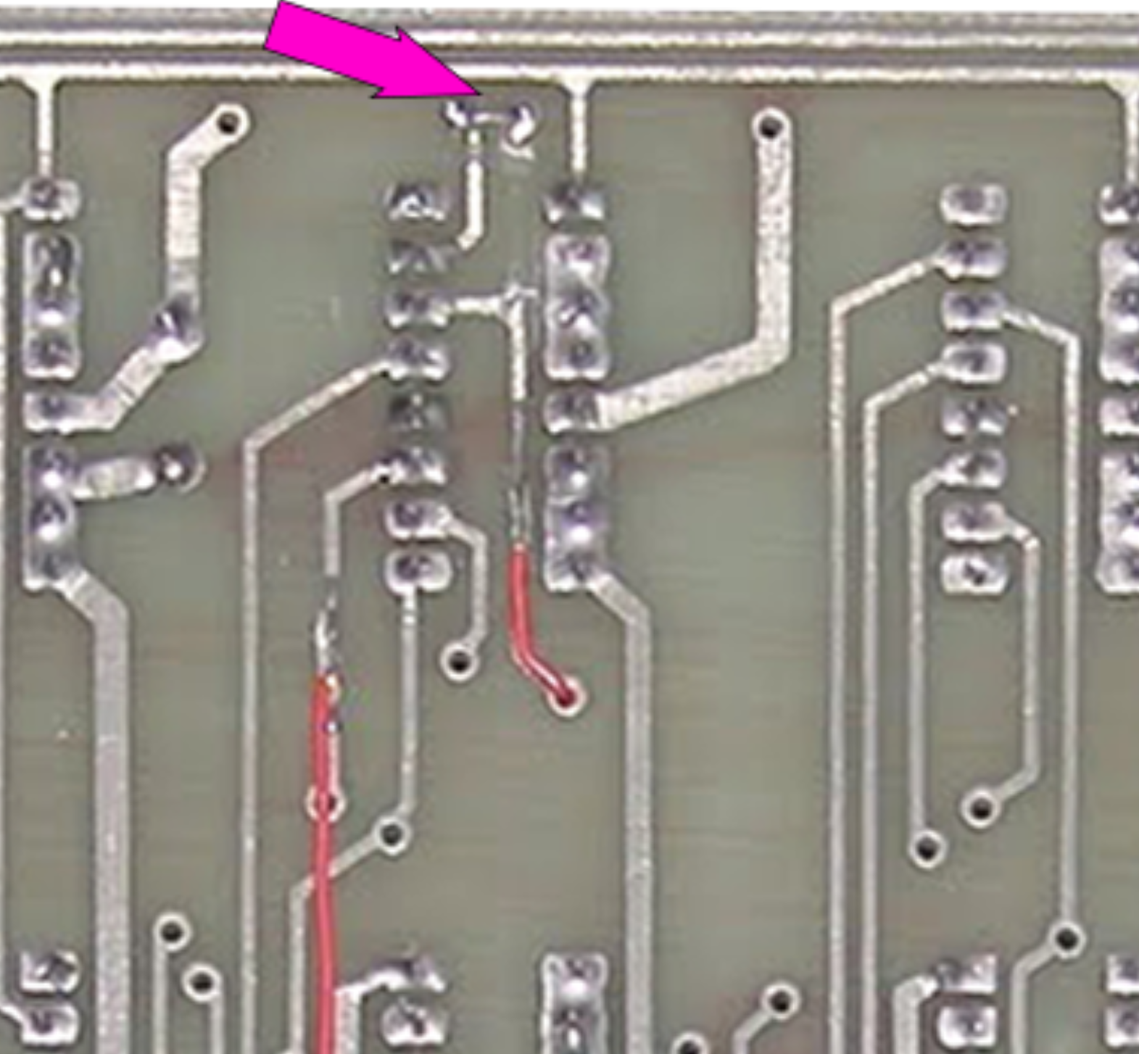

- from front trace cut in step 3 above through via to trace on back of board near pins 6-8 of Z31
